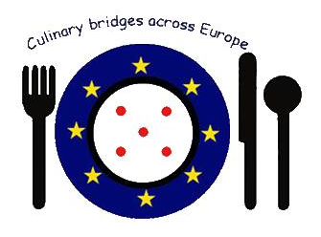
Culinary Bridges across Europe
Team Meeting In Augustów, Poland

Confirmation of Attendance

This is certify that
........................................
Took part in the European Project Meeting in Augustów, Poland
From 23th July 2014 to 27th July 2014

Augustów, 27th July 2014

